WEST HANTS MINOR HOCKEY ASSOCIATION

BIRTHPLACE OF HOCKEY TOURNAMENT

To submit your application and for live scores during tournament weekends, please visit ouf tournament page at:

[WHMHA Birthplace of Hockey Tournament](https://whmhaboht.grayjayleagues.com/)

**Location: West Hants Sports Complex**

16 Centennial Dr, Windsor, NS B0N 2T0

**Newport & District Rink**

1221 NS-215, Newport, NS B0N 2A0

**Registration Fee: $1,000.00**

Upon confirmation of registration payments can be e-transferred to [treasurer@westhantswarriors.com](mailto:treasurer@westhantswarriors.com)

**Divisions:**  **U11C, U13C, U15C and U18C** (8 Teams per division)

**Tournament Dates: U13C & U18C - March 7-9, 2025**

**U11C & U15C - March 14-16, 2025**

Teams confirmed to the tournament will receive:

* a minimum of 3 games
* 1 hour games (3 x 12 minute stop time periods)
* player of the game awards provided to one player from each team after every game

Questions about the tournament can be sent to: [treasurer@westhantswarriors.com](mailto:treasurer@westhantswarriors.com)

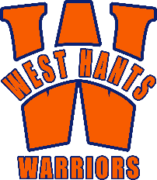**NOTE**: Your team is not confirmed until you receive an email from the Tournament Coordinator - once you receive that email. Payment is due by December 31, 2024.  For refunds or cancellations please review our tournament website refund policy.